**“SPRING-REST-HANDSON”**

**Hands on 1**

**Create a Spring Web Project using Maven**

**1.SpringLearnApplication.java**

package com.cognizant.spring_learn;

import org.slf4j.Logger;

import org.slf4j.LoggerFactory;

import org.springframework.boot.SpringApplication;

import org.springframework.boot.autoconfigure.SpringBootApplication;

@SpringBootApplication

public class SpringLearnApplication {

private static Logger *LOGGER* = LoggerFactory.*getLogger*(SpringLearnApplication.class);

public static void main(String[] args) {

*LOGGER*.info("STARTING: SpringLearnApplication");

SpringApplication.*run*(SpringLearnApplication.class, args);

*LOGGER*.info("STOPPING: SpringLearnApplication");

}

}

**2.HelloController.java**

package com.cognizant.spring_learn.controller;

import org.springframework.web.bind.annotation.RestController;

import org.springframework.web.bind.annotation.GetMapping;

@RestController

public class HelloController {

@GetMapping("/hello")

public String sayHello() {

return "Hello from Spring Boot on port 8082!";

}

}

**3.application.properties**

# Change server port

server.port=8082

# Logging settings

logging.level.root=INFO

logging.level.com.cognizant=DEBUG

# Enable DevTools restart

spring.devtools.restart.enabled=true

# Optional: Customize context path (if needed)

# server.servlet.context-path=/spring-learn

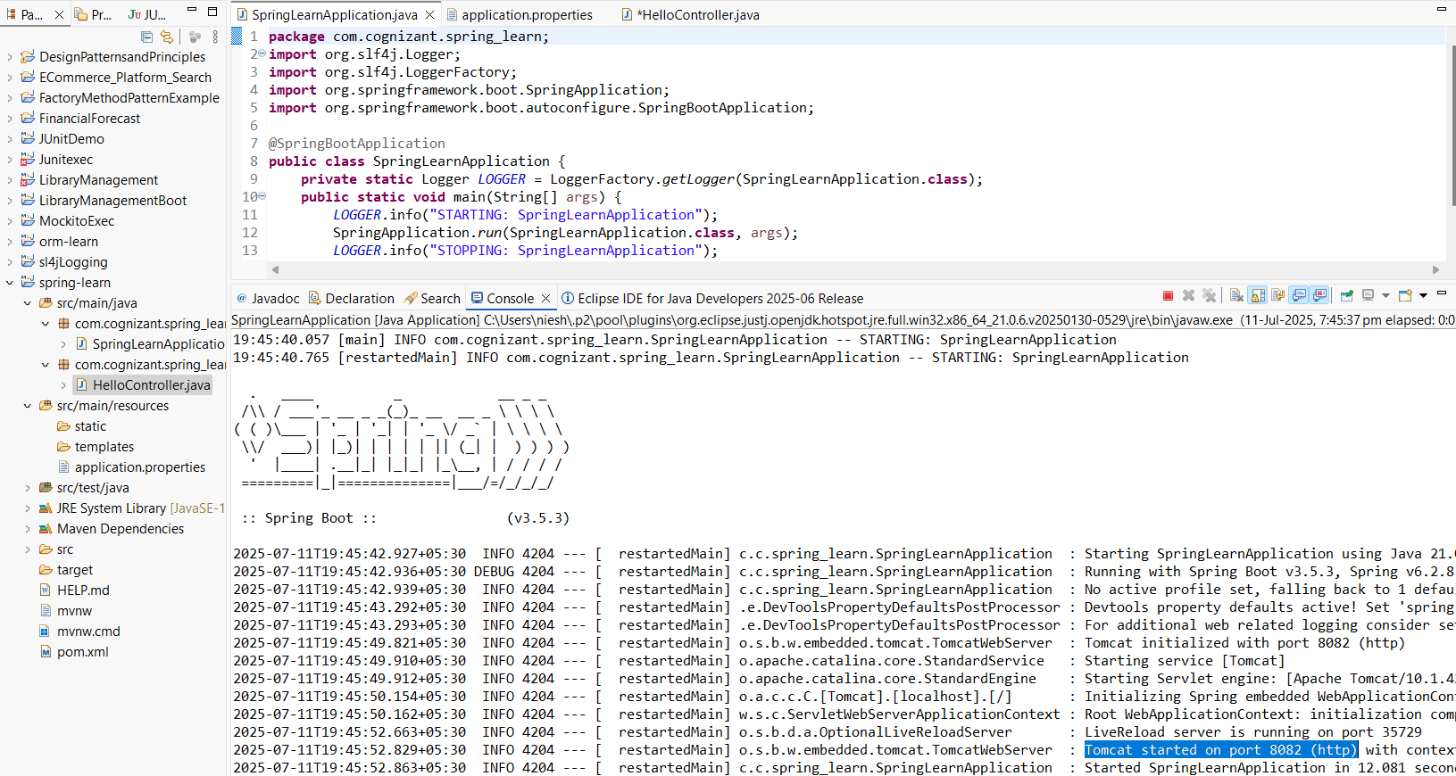

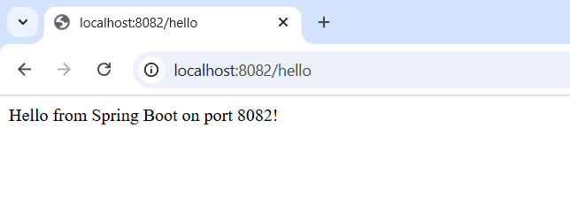

**---------------------------------------------------------------------------------------------------------------------------**

**Hands on 2**

**Spring Core – Load SimpleDateFormat from Spring Configuration XML**

**1.SpringLearnApplication.java**

package com.cognizant.spring_learn;

import java.text.ParseException;

import java.text.SimpleDateFormat;

import java.util.Date;

import org.slf4j.Logger;

import org.slf4j.LoggerFactory;

import org.springframework.boot.autoconfigure.SpringBootApplication;

import org.springframework.context.ApplicationContext;

import org.springframework.context.support.ClassPathXmlApplicationContext;

@SpringBootApplication

public class SpringLearnApplication {

private static final Logger *LOGGER* = LoggerFactory.*getLogger*(SpringLearnApplication.class);

public static void main(String[] args) {

*LOGGER*.info("STARTING: SpringLearnApplication");

*displayDate*();

*LOGGER*.info("STOPPING: SpringLearnApplication");

}

public static void displayDate() {

ApplicationContext context = new ClassPathXmlApplicationContext("date-format.xml");

SimpleDateFormat format = context.getBean("dateFormat", SimpleDateFormat.class);

try {

Date date = format.parse("31/12/2018");

System.*out*.println("Parsed Date: " + date);

} catch (ParseException e) {

System.*out*.println("Failed to parse date: " + e.getMessage());

}

((ClassPathXmlApplicationContext) context).close(); // good practice to close

}

}

**2.date-format.xml**

<?xml version="1.0" encoding="UTF-8"?>

<beans xmlns="http://www.springframework.org/schema/beans"

xmlns:xsi="http://www.w3.org/2001/XMLSchema-instance"

xsi:schemaLocation="http://www.springframework.org/schema/beans

https://www.springframework.org/schema/beans/spring-beans.xsd">

<bean id="dateFormat" class="java.text.SimpleDateFormat">

<constructor-arg value="dd/MM/yyyy" />

</bean>

</beans>

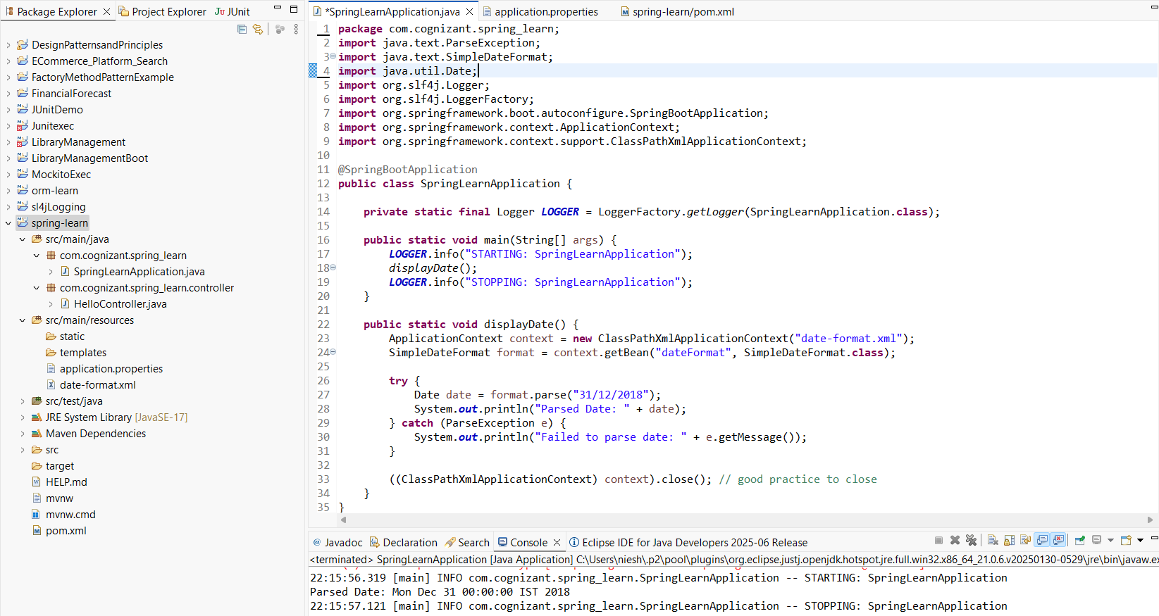

**---------------------------------------------------------------------------------------------------------------------------**

**HandsOn 4**

**Spring Core – Load Country from Spring Configuration XML**

**1.SpringLearnApplication.java**

package com.cognizant.spring_learn;

import com.cognizant.spring_learn.Country;

import org.slf4j.Logger;

import org.slf4j.LoggerFactory;

import org.springframework.boot.autoconfigure.SpringBootApplication;

import org.springframework.context.ApplicationContext;

import org.springframework.context.support.ClassPathXmlApplicationContext;

@SpringBootApplication

public class SpringLearnApplication {

private static final Logger *LOGGER* = LoggerFactory.*getLogger*(SpringLearnApplication.class);

public static void main(String[] args) {

*LOGGER*.info("STARTING: SpringLearnApplication");

*displayCountry*();

*LOGGER*.info("STOPPING: SpringLearnApplication");

}

public static void displayCountry() {

*LOGGER*.info("START");

ApplicationContext context = new ClassPathXmlApplicationContext("country.xml");

Country country = (Country) context.getBean("country", Country.class);

*LOGGER*.debug("Country : {}", country.toString());

((ClassPathXmlApplicationContext) context).close();

*LOGGER*.info("END");

}

}

**2.Country.java**

package com.cognizant.spring_learn;

import org.slf4j.Logger;

import org.slf4j.LoggerFactory;

public class Country {

private static final Logger LOGGER = LoggerFactory.getLogger(Country.class);

private String code;

private String name;

public Country() {

LOGGER.debug("Inside Country Constructor.");

}

public String getCode() {

LOGGER.debug("Getting code: {}", code);

return code;

}

public void setCode(String code) {

LOGGER.debug("Setting code: {}", code);

this.code = code;

}

public String getName() {

LOGGER.debug("Getting name: {}", name);

return name;

}

public void setName(String name) {

LOGGER.debug("Setting name: {}", name);

this.name = name;

}

@Override

public String toString() {

return "Country [code=" + code + ", name=" + name + "]";

}

}



